## CELTA Online Orientation Task 11: Language Grading

The speech bubbles below have the same instructions given by four different teachers. Read the instructions and choose which set of instructions is the most effective. Click on A, B, C or D to indicate your choice.

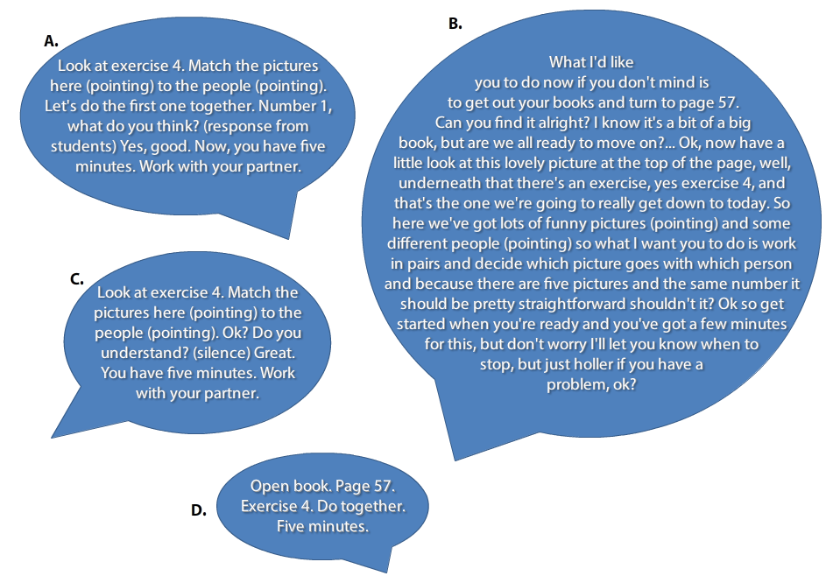

**Commentary**

**A** has the most effective instructions because the teacher talks in clear, simple and concise language. The teacher also uses gestures to show students which exercise to look at. The teacher also does an example with the students to check they have understood the task and give them confidence. The teacher gives a clear time limit.

**B** doesn’t have very effective instructions because they are not concise and the teacher uses quite complex language, for example, *it should be pretty straightforward.* The teacher does not do an example to check the students have understood the instructions.

**C** The instructions are generally clear and concise. However, the teacher does not try to elicit a response from the students when checking that the students have understood the instructions.

**D** The teacher has simplified their language too much and so the language is unnatural, which is not helpful to students. The teacher does not check students have understood what to do.